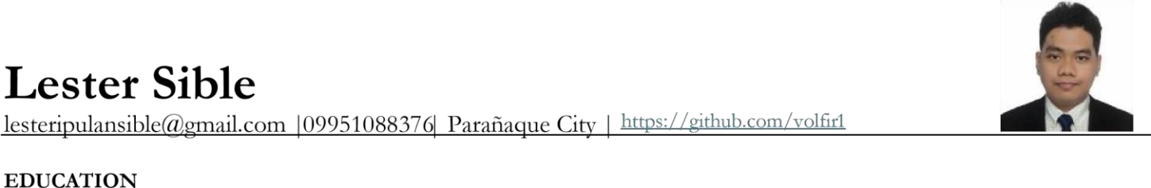
Technological University of the Philippines – Taguig  Bachelor of Science in Information Technology  Relevant Coursework: Web Development, Front End Development, UI/UX Design, Mobile Development, Software Development.  SKILLS AND INTERESTS | August 2026
- IT Support & Operations: Hardware Troubleshooting, PC Assembly & Repair, Windows OS Configuration, Basic Networking (LAN/WLAN Setup).
- Programming Languages: Python, C++, VB.NET, SQL
- Web Development: HTML5, CSS3, JavaScript, React.js, Node.js, Express, PHP (Laravel).
- Soft Skills: Technical Troubleshooting, Team Collaboration, Adaptability, Time Management.

PROJECTS

KCLYNE: Motor Parts Shop and Inventory System
(VB.NET) | Academic Project
- Developed a shop and inventory system for a motor shop using VB.NET and SQL database.
- Role: Frontend Developer.

TheraFlex: Parlor Booking System (Laravel) | Academic Project
- Developed the front-end for a massage parlor service system with scheduling, payment processing, inventory management, and rolebased access control.
- Implemented using PHP Framework (Laravel) with MySQL as database.
- Role: Frontend Developer.

GadgetGalaxy- Web Based E-commerce System (MERN) | Academic Project
- Built a Gadget E-commerce system using MERN stack with Firebase as authentication.
- Implemented using React + Vite for the web frontend, MongoDB as database and NodeJS for server-side process.
- Role: Programmer.

EcoPulse- A mobile and web-based application for renewable energy trend analysis (MERN & Python) | Academic Project
- Developed a web and mobile platform application that uses past data and processed using predictive analytic Model for trend analysis Forecasting future renewable energy trends.
- Role: Frontend & Backend Developer.

PROFESSIONAL DEVELOPMENTS

Data Center, Networking, and Visualization | Oct 2025
- Reviewed hybrid infrastructure models (Azure/AWS), Software-Defined Networking (SDN), and data visualization techniques.
Modern Software Engineering & Mobile Apps | Oct 2025
- Examined end-to-end SDLC, cloud-native methodologies, Docker containerization, and Kubernetes orchestration.
Future Renaissance: Autonomous Machines & Robotics | Sept 2025
- Analyzed AI paradigms (YOLO, SLAM) and assessed hardware-software synchronization of sensors and processors.
Psychology of Fun & Game Testing | Oct 2025
- Executed the complete QA lifecycle, mastering bug prioritization (P1–P3) and technical documentation.
Extended Reality (XR): Virtual & Augmented Reality | Oct 2025
- Acquired technical competency in 3D spatial computing architectures utilizing Unity (C#) and Unreal Engine (C++).
Career Development & Leadership | Oct 2025
- Collaborated in strategic business simulations to refine team management and resource allocation skills.

